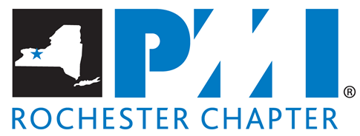

PMI® Rochester Chapter Grant Guidelines
The following sets forth guidelines that the Project Management Institute, Rochester Chapter will rely upon in evaluating requests for grant funds and making grant awards.

The PMI® Rochester Chapter Grants program is designed to meet the Vision and Mission statement of the chapter.

PMI® Rochester Vision:
Organizations in Greater Rochester will embrace, value, and utilize project management and attribute their success to it. Providing grants will support this by sending a message to organizations that project management is a worthwhile investment.

PMI® Rochester Mission Statement:
The Rochester Chapter will be the source and resource to enable our members to improve project, program, and portfolio performance for individuals and organizations in the Greater Rochester Region by fostering a vibrant and engaging community. Providing grants that can be used for training sponsored by local organizations will encourage interactions between like-minded organizations.

This grant program also ties into the PMI® Rochester Chapter Objectives:
- Promote the awareness, practice and profession of Project Management and the PMI®.
- Support the training and professional development of Project Management professionals to improve overall skill level and effectiveness.
- Providing grants will enable chapter members living locally to attend training sessions for project management.
- Advocate acceptance of Project Management as a profession and discipline.
- Encourage and foster the adoption of Project Management practices by corporations, government and other entities.
- Create networking opportunities for Project Management Practitioners.

(1) Eligibility Criteria for Grants
- To be considered for a PMI® Rochester Chapter grant, an applicant must be a member of PMI® Rochester Chapter (including the Ithaca or Student Branches).
- A completed Application Form must be submitted along with an essay.
- The course/training must be completed within six (6) months of receiving the grant award.

(2) What can you apply for?
Any applicant may sign up for Professional Development opportunities (instructor lead training, online classes, etc.) and can request for a grant from the PMI® Rochester Chapter to fund some portion of those development costs.

(3) Who is NOT eligible to apply for a Grant from the PMI® Rochester Chapter?
- Current PMI® Rochester Chapter Board Members.
- Current PMI® Rochester Chapter Grant Review Committee Members.
- Current PMI® Rochester Chapter Director of Grants/Grants and administration of the Grant Process.
4. Anybody who was granted the award within the past 2 years.

(4) Grant Application Amounts:
A grant up to and not exceeding $1000.00 is available to be awarded amongst one or multiple recipients, where the amount awarded is at the discretion of the review committee. The grant awarded is reimbursement for training received and would be up to the amount of the award or up to the training course cost, whichever is lower.

(5) Grant Recipient Responsibilities:
A grant recipient must act on the following before PMI® Rochester Chapter will reimburse the monies granted to the recipient via the award:
- Complete the training within 6 months starting from the day that the grant is awarded and within the same calendar year.
- First pay for the training upfront, show proof of training completion with a pass grade, and provide the receipt of payment.

(6) Grant Application Form
The Grant Application Form can be found on the PMI® Rochester website: http://pmirochester.org/PMI_Rochester_Grants. A completed grant application form must be submitted to the following address: grants@pmirochester.org.

NOTE: Any incomplete forms will not qualify for any further review by the Director of Grants and the supporting review Committee.

(7) Evaluation Criteria for Grants
- The Evaluation Criteria is available upon request.
- The principles behind the Criteria are explained below:
  - Applicant employment status and funding sources.
  - What is the purpose of the training?
  - What is the candidate’s commitment to Project Management?

The PMI® Rochester Chapter does not make grants from its unrestricted funds for:
- Sectarian or religious activities;
- Grants to private foundations;
- Endowments or memorials;
- Direct or grass-roots lobbying efforts; and
- Sustained support for recurring operating expenses

(8) Application Guidelines for Grants
Applicants must complete the PMI® Rochester Chapter grant application form and submit to grants@pmirochester.org by the deadline as indicated in the “(8) Application Schedule for Grants” section. The following must be included in the application.
- Applicant Information
- Essay
- Signature

(9) Application Schedule for Grants
- Summer:
- Open Application Receipt = MAY 7th
- Application Deadline = May 25th / CLOSE APPLICATION RECEIPT
- Announce Winner + Amount = June 15th

- Fall:
- Open Application Receipt = July 23rd
- Application Deadline = August 10th / CLOSE APPLICATION RECEIPT
- Announce Winner + Amount = August 31th

NOTE: Refer to the PMI® Rochester Chapter website for additional information.

(10) Process
The PMI® Rochester Chapter has developed a simple 4-step closed loop process.

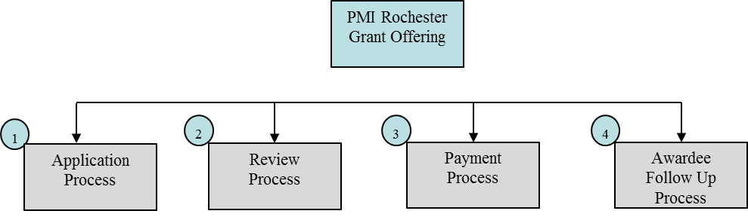

- The applicant fills in and submits a completed grants application form.
- The Director of Grants and the Review Committee will review all applications, rank them based on the Evaluation Criteria and determine a possible winner.
- PMI® Rochester Chapter’s Director of Grants will be assisted by 3-5 Review Committee members who will review applications received, will use the Application Criteria to rank applications and provide their feedback to the Director of Grants.
- The Director of Grants and the Review Committee will meet face to face to discuss the collective feedback.
- If a winner is selected, that applicant will be notified via email and a formal letter will be sent to the applicant announcing their award signed by the President of PMI® Rochester Chapter.
- Non-awardees will also receive a notification informing them of the opportunity to apply in the future for other grants.
- Awardee follow up process will ensure that the Director of Grants confirms:
- Identify Awardees who have completed training
- Validate awardee follow up has been received
- Send Congratulatory letter/send reminder if follow up has not been received
- Document contract breach if awardee doesn’t follow through
  - This candidate will not be eligible in the future
  - Extenuating circumstances will be considered
- Winners info and picture maybe posted on our PMI® Rochester Chapter website, newsletter or displayed at chapter events to advertise and encourage others.

11) Additional Considerations
- PMI® Rochester Chapter reserves the right to discontinue or modify the grant program, or any component thereof, and to revise any or all of the grant requirements, processes, or eligibility criteria at any time.
- Any material misrepresentation of the facts in the prospective grantee’s application and supporting materials, whether discovered during the verification process or later, will result in withdrawal of the application from consideration. Following notice to the prospective grantee of the discovery of the misrepresentation, and the opportunity for the prospective grantee to explain the circumstances of the erroneous submission, the candidate may be banned from applying again for PMI® Rochester Chapter grants in the future if intentional misrepresentation to gain competitive advantage is proven to be true.
- In the remote event that a portion of funds is not allocated, it will be carried forward to the following years grant budget.

