PMI ROC The Project – Student Team Mentor

ROC The Project Overview
This competition is designed to engage college students in the practice of project management and to develop their leadership skills. Student teams from colleges in the Rochester area are given a scenario for which they must provide a solution. They are assigned a certified mentor(s) to teach them how to transform their solutions into project plans using the planning processes documented in the PMBOK. PMO panels judge and provide feedback for each of the four phase gates, which each team must pass through before the final day of the competition. On the final event day, student teams will present their project plans to the PMO panelists in a preliminary round to determine the final four teams that will move forward to have their plans judged by area executives for cash prizes. This day also includes afternoon and evening keynote speakers and a reverse career fair to provide job and internship opportunities for students.

Student Team Mentor Role:
This volunteer position is responsible for leading and ensuring student teams understand the requirements of the PMBOK 6th edition during the ROC THE Project competition. Volunteers should be PMP or CAPM certified, understand PMBOK 6th edition and have a passion to work with students.

1 – 2 Mentors will be assigned to a student team to be the point of contact for questions; coach and prepare the students for understanding project management and the requirements of the scenario; share questions or feedback with the ROC The Project team to help others in this role and ensure the students have a great experience with project management.

Sample Rubric:

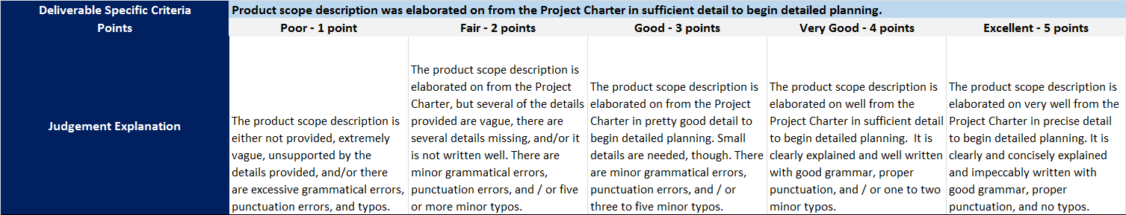

Tasks To Review: Review time commitment & phase schedule. Identify school preferences (top 3). Review communications with student team and ROC The Project team (frequency, responsiveness). Identify topics for discussion. Determine additional required support.

