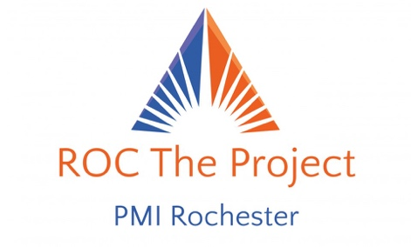
FAQs
- How will information be shared if a Team can’t attend the kick-off?
  - All information will be accessible through the portal located at http://pmirochester.org/ROC_The_Project. Team Mentors will be available to answer any questions.

- Are we following the PMBOK 5th edition or 6th edition?
  - We are following the PMBOK 6th edition.

- Can the mentors get a copy of the judging criteria to help guide the teams?
  - All mentors currently have a copy of the judging criteria (rubric) in their possession.

- What is the expectation for how often the team meets with the mentor? Or is this up to each team?
- Frequency and method is up to the team and the PMI mentor to decide. Mentor and teams can decide the best communication vehicle.

- Are there specific key milestone dates already set for specific deliverables?
  - Yes, those are listed in the portal under Deliverables.

- How can teams get copies of documents/ handouts that explain the project, process, deliverables to be created, dates and requirements for the final presentation?
  - In the portal.

- Can students be from any major and do they need to have taken project management courses?
  - Yes, they can be from any major and no, they don’t need to have taken project management courses.
  - The school determines how they will select the 1-2 teams of 3-6 students
  - Students may or may not have taken project management though that experience will certainly help.
  - This competition is designed to be a positive learning experience about project management skills and philanthropic focus. The selected project will be funded with $15,000 grant for execution with the nonprofit partner MK Gandhi Institute for Non Violence. Students will be able to see tangible results if they choose to engage in the spring on execution.

- Who are the Mentors & What Is Their Role?
  - Mentors are PMP certified individuals that will be assigned to each team for questions, guidance and to understand feedback from the judges

- About the Presentations?
  - The Top Five teams will be selected to present to the MK Gandhi Institute & Executive Judges from local companies.
  - Teams will be notified by 11/2/2019 if they are in the Top Five
  - Presentations will be done at the finale on 11/9/2019
  - It's a tremendous opportunity to present your ideas to the customer.

- How can teams ensure their presentations are “engaging”?
“Engaging” doesn’t have to mean lasers and fireworks (although that’s certainly fun). In the context of a presentation like this, we want to see that the students:

- Demonstrate thoughtfulness for the limitations of resources and constraints (including themselves!) in their approaches;
- Show compassion for all the stakeholders they are serving;
- Exhibit humility in the context of what they are able to solve within the scope of this “wicked” problem (https://en.wikipedia.org/wiki/Wicked_problem)
- Demonstrate, to the extent possible, something that is thought-provoking and different from other approaches given all the above.

If students can do that, they will automatically have us engaged, whether they present using PowerPoint or use lasers and fireworks.

- In what format should the teams input their submissions to the portal?
  - Teams should think through what is the best format for their submissions recognizing that the judges may have different software applications or capabilities with which to view the material. Work with your Mentor to determine
- What is the key report or other technical terms in the rubric?
- Students can do the research to find those answers. Encourage them to do the research themselves.

